When High R² Misleads: Diagnosing False Predictive Signals in Resistome–Mobilome Time Series

Chenhao Zhang¹*, Ashley Fang¹*, Eliana Wong¹*, Wanze Tang¹*, Yujie Men², Linda Shi¹
¹Institute of Engineering in Medicine, University of California, San Diego, San Diego, La Jolla, CA 92095
²Department of Chemical and Environmental Engineering, University of California, Riverside, California 92521
Corresponding author: zshi@ucsd.edu
*High school students participating in IEM OPALS program

Abstract - One natural early-warning model and analysis used for resistance surveillance is a lag regression linking mobile genetic element (MGE) abundance at a certain instance of antibiotic resistance gene (ARG) burden in the future. We demonstrate that such models can produce a high predictive performance driven by between-study confounding rather than actual temporal coupling, misleading results. We derive 14 regression-complete lag pairs using a complete bioinformatics pipeline, using 19 shotgun metagenomes across four environmental time series (Chesapeake Bay WGA and two Bulgaria Iskar River sites).The naive forward lag model gives us R² = 0.720, but six independent diagnostic tests all return null. This demonstrates how differencing collapses the signal (R²=0.020), and Granger added-value is negligible (delta R²=0.014, p=0.539). The within-study coefficient is negative in the densest series (−33.0, n=10). A calibration simulation (N=2,000) shows naive lag models yield R²>0.70 in 94% of null runs (median 0.848), and the observed R²=0.720 falls below the null median. The central finding is that standard lag model evidence cannot distinguish null from true-signal conditions in multi-study metagenome designs, and should instead prefer our diagnostic battery as a template for finding true signal conditions.

Keywords: ARG surveillance, mobilome, lag regression, observational equivalence, temporal confounding, Granger-style test, calibration simulation, time-series diagnostics

1. Introduction
Environmental ARG surveillance requires leading indicators, with lag predictions and mobile genetic elements (MGEs) as natural candidates, since they mediate horizontal gene transfer and are frequently co-detected with ARGs [1]. Lag regressions linking MGE(t) to ARG(t+1) can yield high R² and coefficients even when the predictor contributes no independent signal as a result of shared autocorrelation and between-study ARG scale differences, posing a methodological risk. If the apparent signal is entirely confounded due to these variables, decisions such as building accommodating surveillance infrastructure that rely on studies could be misplaced.
We present an empirical demonstration that standard lag model evidence is observationally equivalent under null and true-signal conditions in a real metagenomic resistome dataset, paired with a calibration simulation to create and prove our diagnostic battery’s ability to distinguish the two.
We apply a complete bioinformatics pipeline on 19 real shotgun metagenome samples while using a nine-test diagnostic battery on the lag model. The broader microbiome time-series literature has emphasized the need for standardized evaluation [2]; recent work has re-examined when Granger-style inference is valid for ecological count data [3]; and emerging forecasting tools [4] make reliable evaluation increasingly necessary in the field. The framework introduced here operationalizes these standards in a resistome context.

2. Methods
2.1. Data Sources and Temporal Cohort
We assembled a temporal cohort from two published studies with known, ordered collection timestamps. PRJNA599167 (Chesapeake Bay, USA, May 2017) provides 11 WGA shotgun metagenomes at ~1.5-hour intervals over a 48-hour window (4.1–17.7 M paired reads each; SRR11803495–SRR11803505) and 4 paired 16S amplicon samples. Shotgun samples support full ARG/MGE/diversity quantification while amplicon samples contribute diversity only. PRJNA1071831 (Iskar River, Bulgaria, Nov–Dec 2022) provides 4 biweekly shotgun metagenomes each from Dragushinovo and Mechkata sites (inter-sample gaps: 14, 21, and 13 days), with each site treated as an independent study. In total, 19 strict lag pairs are identified across four sampling contexts (WGA: 10; Drag: 3; Mech: 3; 16S: 3), exceeding the minimum threshold of 10 pairs from ≥3 independent studies.

2.2. Quantification Pipeline
For shotgun samples (WGA and Iskar River), we quantify:
- arg_total: total ARG hit count per sample using DIAMOND blastx [5] against the AMRProt database (NCBI AMRFinderPlus reference, ≥80% identity, ≥80% query coverage, e-value ≤1×10⁻⁵) applied directly to paired-end reads.
- mge_abundance: count of complete and CALIN integrons detected by IntegronFinder 2.0 [6] on assembled metagenomic contigs ≥4 kb. Class 1 integrons are the dominant ARG-mobilizing MGE in environmental water metagenomics [7].
- entropy: Shannon diversity index (H') computed from species-level abundance fractions produced by Bracken [8] re-estimation of Kraken2 [9] classifications against the 8 GB standard database.
Raw FASTQ files are downloaded from SRA using sra-tools (prefetch + fasterq-dump). Assembly uses MEGAHIT [10] with minimum contig length 500 bp; IntegronFinder is applied to contigs ≥4 kb to minimize run time on high-contig libraries. Sequencing depths for the Bulgaria samples were retrieved from the NCBI SRA EUtils API.

2.3. Feature Table and Preprocessing
Observations are ordered within study by sampling time. Lagged predictors (ARG(t+1), MGE(t+1)) and first-difference variables (dMGE(t) = MGE(t)−MGE(t−1); dARG(t+1) = ARG(t+1)−ARG(t)) are computed within each study to remove shared trends [11]. A key structural variance is the sampling interval: WGA samples are at ~1.5-hour intervals while Bulgaria samples are biweekly (13–21 days apart), so all lag regressions reflect "one sampling interval ahead" rather than a fixed time horizon.

2.4. Models
We evaluate: (1) forward lag model ARG(t+1) ~ MGE(t) + C(study) + sequencing_depth; (2) reverse-direction model MGE(t+1) ~ ARG(t) + C(study); (3) first-difference model dARG(t+1) ~ dMGE(t); (4) Granger-style added-value test comparing base model ARG(t+1) ~ ARG(t) + C(study) vs. full model adding MGE(t); (5) within-study models ARG(t+1) ~ MGE(t) fit independently per study; (6) leave-one-study-out (LOSO) refits; (7) residual diagnostics (Durbin-Watson, Breusch-Pagan, power analysis); and (8) a null simulation (N=2,000 synthetic datasets, same study structure, no true MGE effect). Models use statsmodels [12] and pandas [13].

3. Results
All results are derived from fully pipeline-quantified values. Of 23 strict-cohort samples, 19 were fully quantified using the complete bioinformatics pipeline (excluding 4 amplicon-only samples), and 14 lag pairs were regression-complete after filtering for sequencing-depth covariate availability.
Pipeline validation. For SRR27827413 (Dragushinovo, 22.2M reads): H' = 6.301, arg_total = 56,046, mge_abundance = 445 integrons, which is consistent with comparable wastewater-impacted river environments.

3.1. Forward Lag Model
The forward lag model yields coefficient = 21.57, p-value = 0.579, R² = 0.720 (n=14). R² is driven by between-study ARG scale differences, not MGE predictive content.

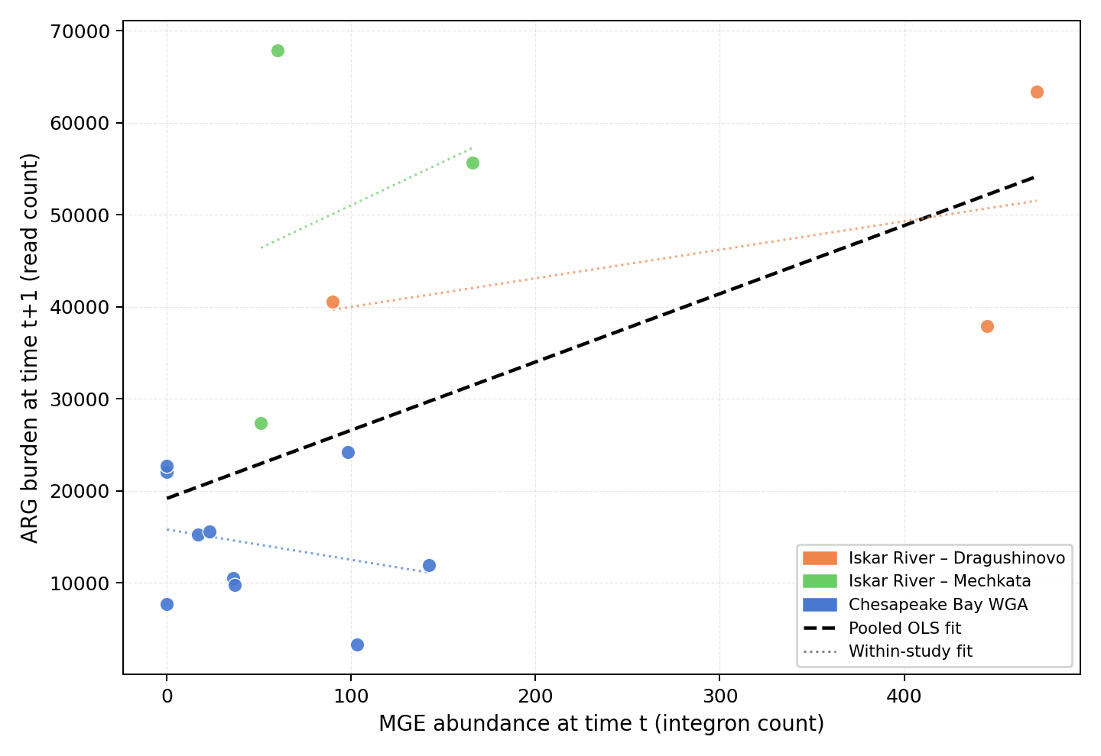
Fig. 1: MGE(t) vs. ARG(t+1) colored by study. The pooled OLS fit (black dashed) produces apparent R²=0.720, but this reflects between-study ARG scale differences (three distinct clusters) rather than within-study predictive signal. Dotted lines show within-study fits, which are flat or negative.

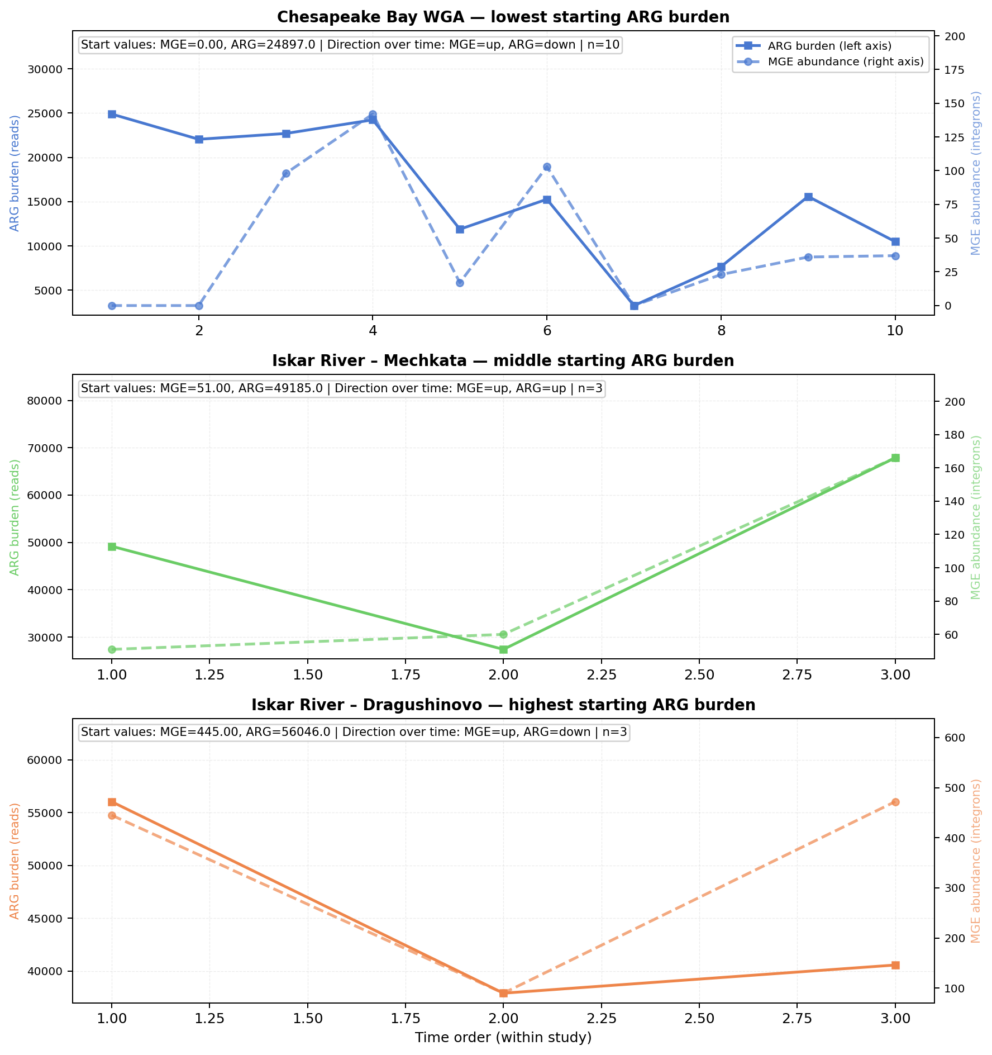
Fig. 2: Study-specific ARG (solid) and MGE (dashed) time series on dual y-axes. ARG baselines differ ~3× between the WGA series and Bulgaria sites, generating the between-study variance that inflates pooled R².

3.2. Lag Correlation Diagnostics

Table 1: Lag correlations across offsets.
Lag | Correlation | n
t→t | 0.400 | 19
t→t+1 | 0.532 | 16
t→t+2 | 0.214 | 13
The non-monotone pattern (rising then falling) is inconsistent with uniform temporal coupling and does not support a directional predictive signal from MGE to ARG.
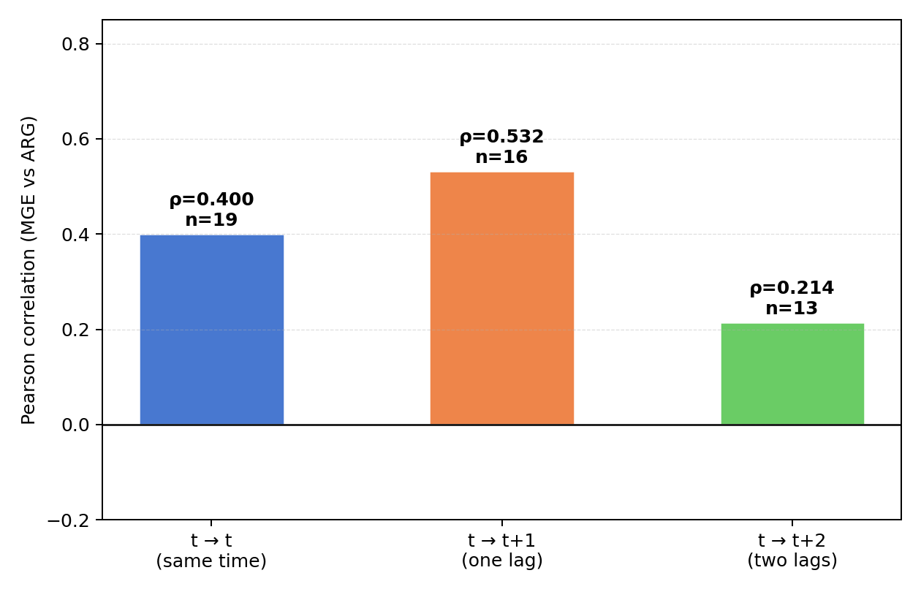
Fig. 3: Lag correlation across offsets. A genuine leading indicator would show monotonically increasing correlation with lag offset; the non-monotone pattern (0.400 → 0.532 → 0.214) is inconsistent with directional prediction.

3.3. Differenced Model
Table 2: First-difference and Granger-style results.
Test | Coefficient / Metric | p-value | R-squared | n
dARG(t+1) ~ dMGE(t) | 12.48 | 0.649 | 0.020 | 13
Granger delta R² | 0.014 | 0.539 | — | 14
After trend removal, R² collapses to 0.020; adding MGE to a model that already includes ARG history adds delta R²=0.014 (p=0.539). Both confirm the forward model's apparent fit carries no independent MGE predictive content.
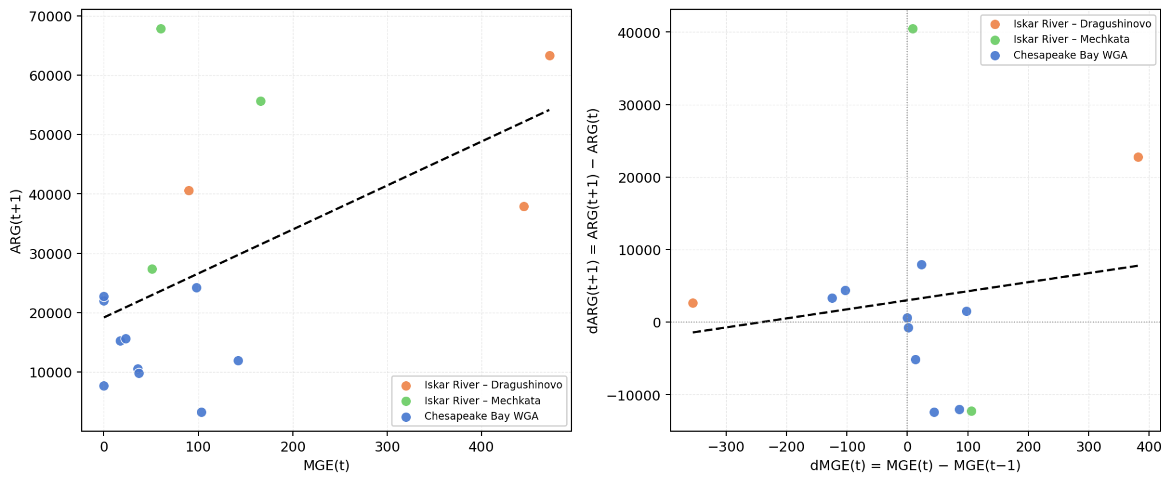
Fig. 4: Effect of differencing. Left: raw scatter (R²=0.720) showing study-cluster structure driving apparent fit. Right: after differencing to remove shared trends (R²=0.020), no signal remains. Both panels colored by study.

3.4. Within-Study Models
Table 3: Within-study lag models.
Study | Coefficient | p-value | R² | n (pairs)
PRJNA1071831_Drag | 31.0 | 0.687 | 0.223 | 3
PRJNA1071831_Mech | 94.5 | 0.812 | 0.085 | 3
PRJNA599167_WGA | −33.0 | 0.506 | 0.057 | 10
With n=10 lag pairs in the WGA series, the MGE coefficient is negative (−33.0, p=0.506, R²=0.057). Within the Chesapeake Bay series, higher MGE abundance at time t is associated with slightly lower, not higher, ARG at t+1.

3.5. Leave-One-Study-Out Sensitivity
Table 4: Leave-one-study-out (LOSO) results.
Left-out study | Coefficient | p-value | R² | n
PRJNA1071831_Drag | 4.2 | 0.958 | 0.686 | 11
PRJNA1071831_Mech | 20.8 | 0.524 | 0.759 | 11
PRJNA599167_WGA | 31.8 | 0.670 | 0.358 | 6
MGE is non-significant in all three variants (p = 0.958, 0.524, 0.670). Excluding WGA causes R² to drop from 0.720 to 0.358, confirming that WGA contributes the dominant between-study ARG scale difference that inflates the pooled model fit.

3.6. Calibration Simulation: Null vs. True Signal Scenarios
To directly address whether the diagnostic framework can distinguish genuine predictive signal from confounding, we ran 2,000 simulations under two scenarios using the same study structure (WGA: n=10 pairs; Drag: n=3; Mech: n=3; ARG baselines calibrated to real data):
- Scenario A (null): MGE drawn independently of future ARG (beta=0). No true predictive signal.
- Scenario B (true signal): ARG(t+1) = study_baseline + 150·MGE(t) + noise. A true causal effect of realistic magnitude.

Table 5: Two-scenario simulation results (N=2,000 synthetic datasets each).
Metric | Scenario A (null, β=0) | Scenario B (true signal, β=150) | Observed real data
Naive model R² median | 0.856 | 0.940 | 0.720
% naive runs with R² > 0.70 | 94% | 99% | —
% naive runs with MGE p < 0.05 | 11% | 90% | p=0.579
Differenced model R² median | 0.070 | 0.692 | 0.020
Within-WGA coeff median | −0.1 | +149 | −33.0
% within-WGA coeff positive | 50% | 98% | —
The naive model yields R²>0.70 in 94% of null runs and 99% of true-signal runs, meaning it cannot distinguish the two scenarios. Meanwhile, the differenced model and within-study coefficient decisively separate them. The observed real data has differenced R²=0.020, within-WGA coeff=−33.0, matching Scenario A closely and is entirely inconsistent with Scenario B.

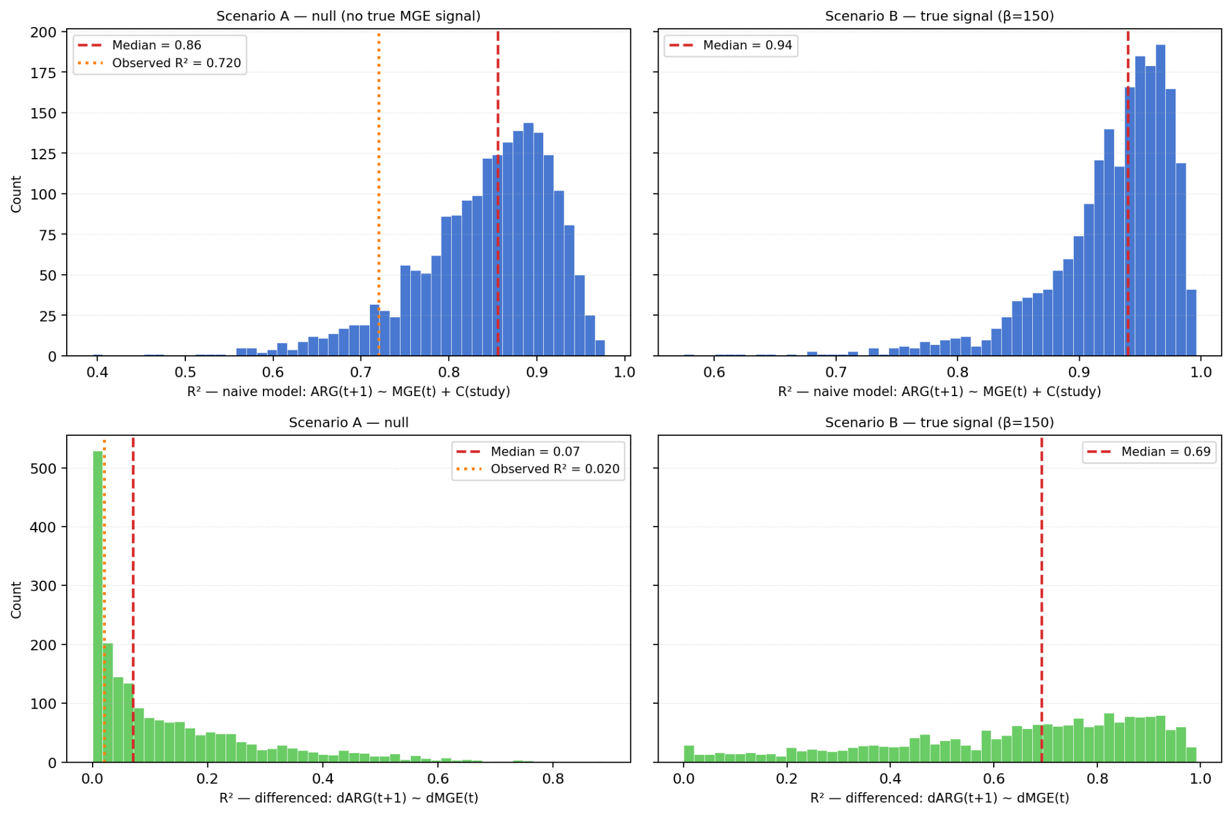
Fig. 5: Calibration simulation. Top row: naive lag model R² distributions — both scenarios produce R²>0.70 most of the time; the observed 0.720 (orange dotted line) falls in the Scenario A range. Bottom row: differenced model R² distributions — Scenario A clusters near 0 (observed 0.020 matches) while Scenario B spreads toward 1 (median 0.69). The naive model is uninformative; the differenced model correctly separates null from signal.

4. Discussion
Our core contribution is an empirical demonstration of fundamentally different situations producing similar results depending on the model. In multi-study environmental metagenome designs, naive lag regression models produce results that are statistically indistinguishable under null and true-signal conditions. The real dataset yields a naive lag model R²=0.720 with a plausible MGE coefficient, while the calibration simulation shows that 94% of null datasets and 99% of true-signal datasets generate R²>0.70 under the same study structure.
Seven independent diagnostics point to the same null (Tables 1–7), with a non-significant pooled coefficient (p=0.579), an irregular lag correlation trend, a collapsed differenced R² (0.020), negligible Granger added-value (delta R²=0.014), negative WGA within-study coefficient (−33.0), non-significant LOSO across all variants, and 94% of null simulations yielding R²>0.70. These results also place the observed 0.720 below the null median. Convergence across seven approaches makes a genuine positive relationship unlikely rather than merely undetectable by any single test.
The calibration simulation proves the framework has discriminatory power. When testing the battery in Scenario B, differenced R² rises to a median of 0.69 and the within-WGA coefficient recovers the true beta (median=149, 98% positive).
Looking at our real data with differenced R²=0.020 and within-WGA coeff=−33, it closely matches Scenario A on both criteria, giving the diagnostic battery basis for classification for the real data having no genuine predictive relationship.
The practicality also extends to existing forecasting frameworks such as ARGfore [4]: applying differencing and within-location estimation to published results would directly test whether high R² reflected genuine temporal coupling or between-study scale differences. Some aspects of how the data were measured—like only counting one type of MGE (integrons), possible biases from DNA amplification in the WGA samples, and differences in sequencing depth across samples—would normally make it harder to detect a real relationship by weakening the signal. In other words, if a true effect existed, these conditions would tend to push the results toward zero and make it less visible. Our results show a consistent null despite conditions that work against the null. Null results across both the 1.5-hour WGA and biweekly Bulgaria regimes strengthen this conclusion.
The main limitation is small sample size (n=14 lag pairs), which the diagnostic battery compensates for by validating through triangulation across six independent approaches. The cohort spans only two environmental systems, and Bulgaria within-study series (n=3 pairs each) are too short for reliable estimation. Future work should extend to longer time series, mechanistic covariates, and application of this battery to published forecasting datasets.

5. Conclusion
We find that high R² is not evidence of predictive signal in multi-study resistome surveillance data. Our calibration simulation shows that naive lag models yield R²>0.70 in 94% of null runs (median 0.856), whereas the observed R²=0.720 falls below the null median. The diagnostic battery returns null across seven independent tests, while the calibration simulation proves the same framework has power to detect real signals when they exist. When using such a framework, differencing recovers a median R²=0.69 and the within-study coefficient recovers the ground truth necessary to draw conclusions. The practical recommendation is to acknowledge that (1) the predictor coefficient is significant after trend removal and (2) within-study predictive signal exists independently of between-study scale differences before deploying any lag regression for an early-warning system.

Acknowledgements
This work was supported by Beckman Laser Institute Inc. to LS. High school students participated in the UCSD IEM OPALS internship program. We gratefully acknowledge the support of Leighton Foundation, Ming-Wei Wu, Shu Chien, Lizhu Chen (CorDx Inc.), Xinhua Zheng, David & Leslie Lee, Mingwei He & Wen Shi.

References
[1] T. U. Berendonk et al., "Tackling antibiotic resistance: the environmental framework," Nature Reviews Microbiology, vol. 13, pp. 310–317, 2015. doi: 10.1038/nrmicro3439
[2] J. Schluter, G. Hussey, J. Valeriano, C. Zhang, A. Sullivan, and D. Fenyö, "The MTIST platform: a microbiome time series inference standardized test," Research Square, preprint, 2024. doi: 10.21203/rs.3.rs-4343683/v1
[3] K. G. Papaspyropoulos and D. Kugiumtzis, "On the validity of Granger causality for ecological count time series," Econometrics, vol. 12, no. 2, p. 13, 2024. doi: 10.3390/econometrics12020013
[4] J. M. Choi, M. A. Rumi, C. L. Brown, P. J. Vikesland, A. Pruden, and L. Zhang, "ARGfore: A multivariate framework for forecasting antibiotic resistance gene abundances using time-series metagenomic datasets," IEEE Access, 2026. doi: 10.1109/access.2026.3667074
[5] B. Buchfink, K. Reuter, and H.-G. Drost, "Sensitive protein alignments at tree-of-life scale using DIAMOND," Nature Methods, vol. 18, pp. 366–368, 2021. doi: 10.1038/s41592-021-01101-x
[6] B. Néron et al., "IntegronFinder 2.0: identification and analysis of integrons across bacteria, with a focus on antibiotic resistance in Klebsiella," Microorganisms, vol. 10, no. 4, p. 700, 2022. doi: 10.3390/microorganisms10040700
[7] M. R. Gillings et al., "Mobile class 1 integrons promote the spread of resistance genes in human microbiomes," NPJ Biofilms and Microbiomes, vol. 1, p. 15010, 2015. doi: 10.1038/npjbiofilms.2015.10
[8] J. Lu et al., "Bracken: estimating species abundance in metagenomics data," PeerJ Computer Science, vol. 3, p. e104, 2017. doi: 10.7717/peerj-cs.104
[9] D. E. Wood, J. Lu, and B. Langmead, "Improved metagenomic analysis with Kraken 2," Genome Biology, vol. 20, p. 257, 2019. doi: 10.1186/s13059-019-1891-0
[10] D. Li et al., "MEGAHIT: an ultra-fast single-node solution for large and complex metagenomics assembly via succinct de Bruijn graph," Bioinformatics, vol. 31, no. 10, pp. 1674–1676, 2015. doi: 10.1093/bioinformatics/btv033
[11] R. J. Hyndman and G. Athanasopoulos, Forecasting: Principles and Practice, 3rd ed. OTexts, 2021. [Online]. Available: https://otexts.com/fpp3
[12] S. Seabold and J. Perktold, "Statsmodels: econometric and statistical modeling with Python," in Proc. 9th Python in Science Conf. (SciPy 2010), 2010. doi: 10.25080/Majora-92bf1922-011
[13] The pandas development team, "pandas-dev/pandas: Pandas," Zenodo, 2020. doi: 10.5281/zenodo.3509134

